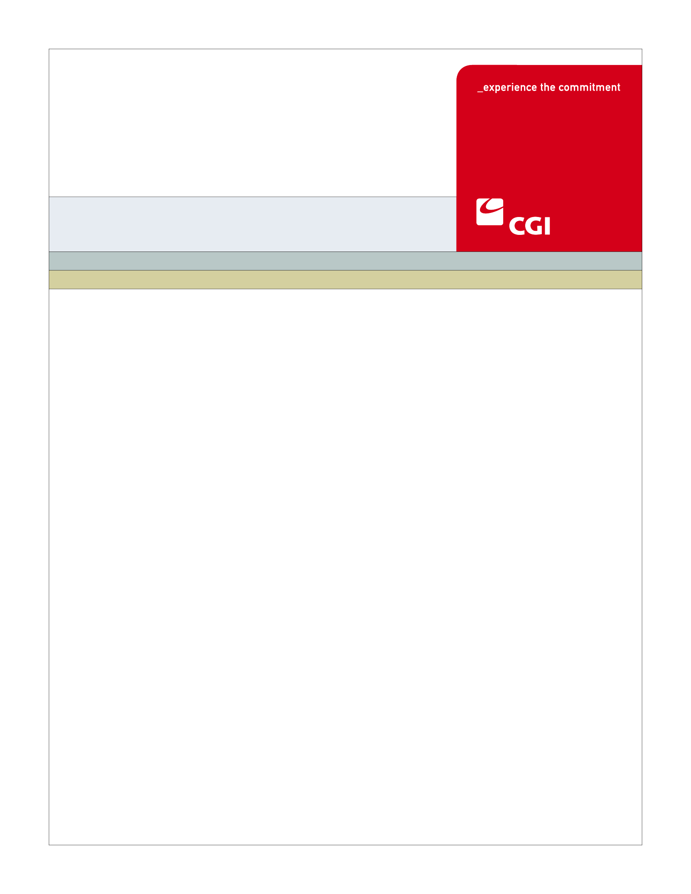

USE
Colorado Health Benefit Exchange (COHBE)
Version 0.1
August 23, 2012
BN-001A Third Party Certification (Broker)
Use Case
REVISION HISTORY
Version | Date | Modified By | Description
0.1 | 2012-08-23 | Derek Sullivan | Initial Draft
0.1 | 2012-08-24 | John Williams | Reviewed Initial Draft of Use Case
0.1 | 2012-08-28 | Tim Welch | Reviewed Initial Draft of Use Case

TABLE OF CONTENTS
1 Use Case: Broker Certification 6
1.1 Goal 6
1.2 Brief Description 6
1.3 Requirements Traceability 6
1.4 Primary Actor(s) 6
1.4.1 Back Office 6
1.4.2 Exchange 6
1.5 Secondary Actor(s) 7
1.5.1 Broker 7
1.5.2 DOI 7
1.5.3 LMS 7
1.5.4 Carrier 7
1.6 Pre-Conditions 7
1.7 Successful Post-Conditions 7
1.8 Triggers 7
1.9 Assumptions 7
2 Flow of Events 8
2.1 Basic (Main) Flow – Broker Certification 10
2.1.1 Checks Licensed Broker List 10
2.1.2 Has Broker License Been Verified? 10
2.1.3 Checks LMS Third Party Training Completion 10
2.1.4 Checks Broker Appointment 10
2.1.5 Is Appointment Check Successful? 10
2.1.6 Has Broker Completed COHBE Broker Training? 10
2.1.7 Updates Broker Account to Business Ready 10
2.1.8 Adds Broker to Certified Broker List 10
2.1.9 Receives Account Notification Allowing Broker to do Business on the Exchange 11
2.1.10 Provides Licensed Broker List 11
2.1.11 Provides Third Party Training Completion List 11
2.1.12 Provides Appointment Feed 11
2.1.13 Next Steps 11
3 Alternate Flows 11
3.1 License Discrepancy Compliance 11
3.1.1 Checks Licensed Broker List Discrepancy 11
3.1.2 Has Back Office Resolved License Discrepancy 12
3.1.3 Initiates Broker License Discrepancy Notification 12
3.1.4 Does Broker Want to Resolve License Discrepancy? 12
3.1.5 Notify Exchange of DOI Resolution 12
3.1.6 Checks DOI Resolution 12
3.2 Facilitates Carrier Appointment 12
3.3 COHBE Broker Training Completion 12
3.3.1 Does Broker Want to Participate in COHBE Broker Training? 12
3.3.2 Resolve COHBE Broker Training Discrepancy 12
4 Exception Flows 13
5 Specifications 14
5.1 Business Rules 14
5.1.1 Broker License Verification 14
5.1.2 LMS Third Party Training Verification 14
5.1.3 Carrier Appointments 15
5.1.4 Business Recertification 15
5.2 Process Rules 15
5.2.1 Has Broker License Been Verified? 15
5.2.2 Has Broker Completed COHBE Broker Training? 15
5.2.3 Is Appointment Check Successful? 15
5.3 Workflow 16
5.3.1 Worklist Definitions 16
5.4 UI Screen Details 16
5.4.1 UI Flow Considerations 16
5.5 Communications 17
5.5.1 Imaging Requirements 17
5.5.2 Form Requirements 17
5.5.3 Notices Requirements 17
5.5.4 Other Communication Requirements 18
5.6 Interfaces 18
5.7 Reporting 18
5.7.1 Broker Training List 18
5.7.2 Certified Brokers 18
5.8 User Security 18
5.9 Activity Log and Audit Trail 18
6 Future Release Notes 19
7 Appendix A - Glossary 19

Use Case: Broker Certification

Goal
The goal of this Use Case is to certify a Broker to use the Exchange.
This Use Case completes succesfully when the Broker is certified by the Exchange and their account is updated indicating they may conduct business on the Exchange.

Brief Description
Before this Use Case begins, the Create Broker Account Use Case must be completed in order for the Exchange to initiate the certification process. Once a Broker is provided with an account, the Exchange will begin its certification process.
This process will include checking the Broker against the DOI provided list of licensed Brokers as well as ensuring that the Broker has completed the COHBE specific Broker training through the Learning Management System (LMS). Notifications and reminders will be provided throughout the certification process. Once certified, the Broker’s account will be modified by the Exchange to indicate that the Broker is now allowed to conduct business on the Exchange.

Requirements Traceability
The following requirement is covered within this Use Case:
- SH124: The Exchange shall only allow brokers and navigators who have completed training on the Learning Management System (LMS) to be certified.

Primary Actor(s)

Back Office
The Back Office will manually check the licensed Broker list and resolve the discrepancy or initiate a Broker license discrepancy notification to the Broker.

Exchange
The Exchange will conduct the automated certification process and update the Brokers account reflecting the certification process.

Secondary Actor(s)

Broker
If required, the Broker will provide additional supporting materials.

DOI
DOI will provide the Exchange with a monthly list of licensed Brokers in the state.

LMS
The Learning Management System will provide the Exchange with a daily list of Brokers that have completed COHBE Broker training.

Carrier
The Carriers will provide the Exchange a monthly Broker appointment feed.

Pre-Conditions
This Use Case begins after:
- The Broker will have established an account on the Broker Portal and will have provided his/her Broker identification number.
- DOI will have provided the Exchange with a monthly list of licensed Brokers.
- LMS will have provided the Exchange with a daily list of Brokers who have completed training.

Successful Post-Conditions
The Use Case completes when:
- The Broker is certified and the Exchange has updated his/her account to a status that allows the Broker to conduct business on the Exchange.

Triggers
The following events would trigger this Use Case:
- A Broker has created an account on the Broker Portal. The Broker Portal initiates the certification process for the Broker.

Assumptions
The Exchange will be notified that a Broker has established an account which will allow the Exchange to initiate the Broker certification process.
DOI and LMS will provide all required lists to the Exchange in order to complete the certification process.
DOI and LMS will capture and track Broker license numbers.
LMS will provide a partial training completion list to the data warehouse and the LMS user.
GAP - My Learning - Appeal Certification Status
GAP - My Learning - Track Certification Status
GAP - Facilitate Broker Appointments
GAP – Decertification
GAP – Continuing Education Certification Requirements
GAP – Broker specifying which Exchange(s) he/she intends to participate on

Flow of Events
The Business Process Activity diagram below shows the processes for the Broker Certification Use Case. The steps numbered on the diagram below have detailed explanations in the sections that follow.
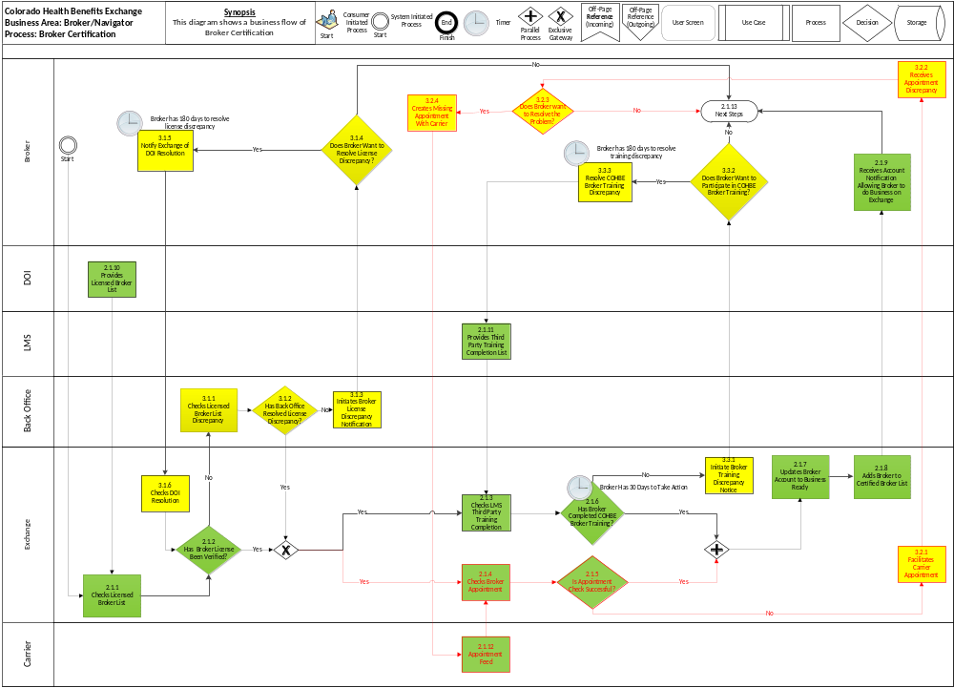
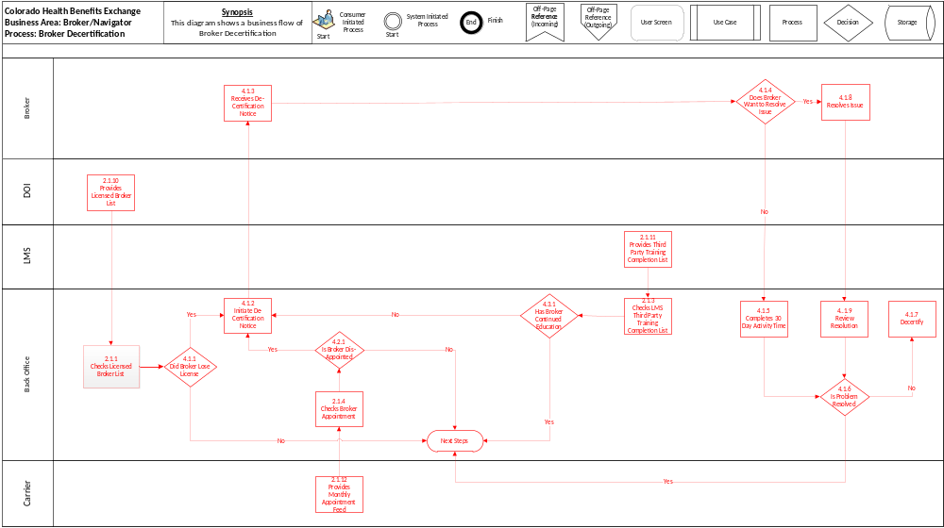

Basic (Main) Flow – Broker Certification
The Basic Flow through this Use Case is the Exchange initiating the certification process after the Broker has created an account on the Exchange which will allow the Broker to conduct business on the Exchange.

Checks Licensed Broker List
The Exchange verifies the Broker against the DOI supplied licensed Broker list (Business Rule 5.1.1).

Has Broker License Been Verified?
Based on the outcome of the DOI license check, the BPM layer will progress the certification process to the next appropriate step (Process Rule 5.2.1).

Checks LMS Third Party Training Completion
The Exchange will verify the Broker as having completed the COHBE specific training in order to conduct business on the Exchange (This may be a manual process for go live) (Business Rule 5.1.2).

Checks Broker Appointment
(This may be a manual process for go live) (Business Rule 5.1.4) – GAP

Is Appointment Check Successful?
GAP

Has Broker Completed COHBE Broker Training?
Based on the outcome of the Broker check, the BPM layer will progress the certification process to the next appropriate step (Process Rule 5.2.2).

Updates Broker Account to Business Ready
After the Exchange determines the Broker is licensed and has completed COHBE Broker training, the Exchange will update the Broker’s account to the state of being certified to conduct business on the Exchange (Process Step 5.2.2, 5.2.3).

Adds Broker to Certified Broker List
After the Broker’s account has been updated, the Exchange will add the Broker to the Certified Broker List, which will list the Broker’s contact information in the SHOP and Individual Exchanges. This will be a data table that is maintained by CGI/COHBE. hCentive will simply be loading that as a directory of certified brokers.
- The specific information included is:
- Broker name (First Name, Middle Name, Last Name as entered on create Broker account)
- Logo
- Email
- Website URL
- Phone Number
- Agency Name (will be impacted by account hierarchy CR)

Receives Account Notification Allowing Broker to do Business on the Exchange
An email will be sent to notify the Broker that they are now allowed to conduct business on the Exchange (Notices Requirements 5.5.3).

Provides Licensed Broker List
DOI will provide the Exchange with a list of licensed Brokers (Business Rule 5.1.1).

Provides Third Party Training Completion List
LMS will provide the Exchange with a list of Third Parties that have completed COHBE Broker Training (Business Rule 5.1.2).

Provides Appointment Feed
(Business Rule 5.1.4) - GAP

Next Steps
The user proceeds to possible next steps, such as:
- The Broker chooses not to comply with DOI license standards (End).
- The Broker chooses not to complete COHBE LMS training (End).
- The Broker successfully completes certification and can log on and conduct business on the Exchange.
- The Broker chooses not to resolve the appointment feed from the carriers (End).

Alternate Flows

License Discrepancy Compliance
The Licensing Discrepancy Compliance Alternate Flow takes place after the Broker creates an account on the Exchange and the Exchange cannot verify the Broker license.

Checks Licensed Broker List Discrepancy
The Back Office manually verifies the discrepancy against the DOI supplied licensed Broker list (Business Rule 5.1.1).

Has Back Office Resolved License Discrepancy
Based on the outcome of the DOI license check, the Back Office will progress the certification process to the next appropriate step (Process Rule 5.2.1).

Initiates Broker License Discrepancy Notification
When the Back Office cannot verify a Broker as being licensed, a discrepancy notification will be sent to the Broker (Notification 5.5.3).

Does Broker Want to Resolve License Discrepancy?
The Broker has the choice to resolve the discrepancy within 180 days. The Broker will be allowed to login and check their current certification status on the Exchange (pending DOI or COHBE authorization, authorization denied/approved).

Notify Exchange of DOI Resolution
The Broker provides additional documentation through the Broker portal account to resolve the discrepancy; proceed to the “Checks DOI Resolution” process step, 3.1.6.

Checks DOI Resolution
The Exchange verifies the Broker against the DOI resolution materials; proceed to the “Has Broker License Been Verified” process step, 2.1.2.

Facilitates Carrier Appointment
3.2.1 through 3.2.4 - GAP

COHBE Broker Training Completion
The COHBE Broker Training Completion Alternate Flow takes place after the Broker is verified as licensed and the Exchange determines the Broker has not completed the COHBE specific training.

Does Broker Want to Participate in COHBE Broker Training?
The Broker has the choice to complete training. The Broker will be allowed to login and check their current certification status on the Exchange (pending LMS authorization, authorization denied/approved).

Resolve COHBE Broker Training Discrepancy
The Broker completes COHBE Broker training on LMS within 180 days; proceed to the “Checks LMS Broker Training Completion List” process step, 2.1.3.

Exception Flows
Broker Decertification BPM – GAP
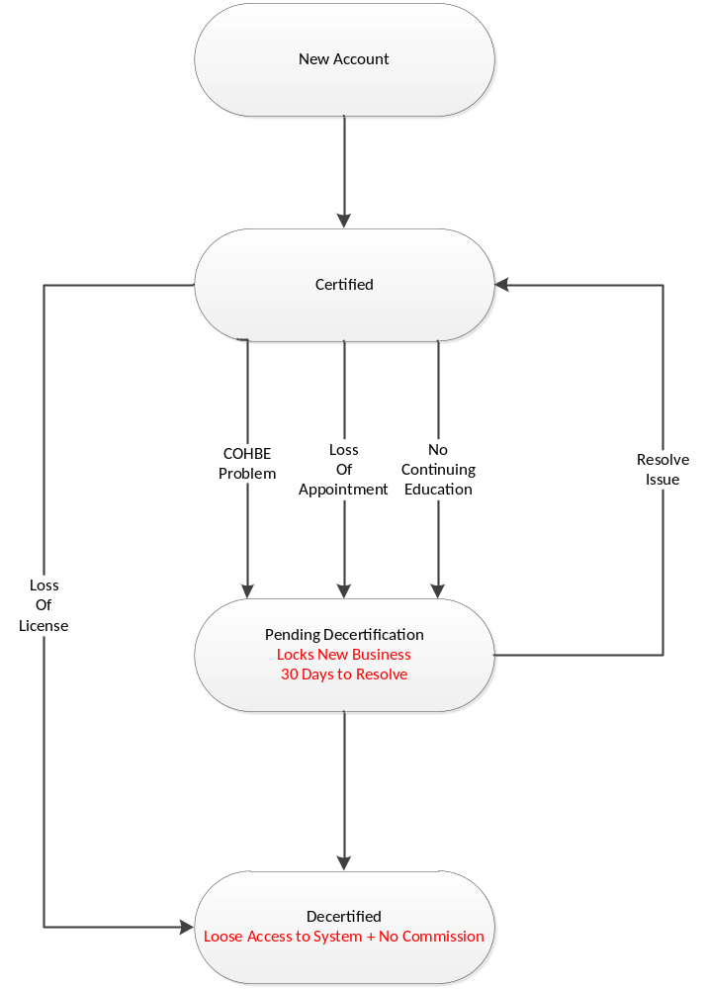

Specifications

Business Rules

Broker License Verification
DOI provides the Exchange with a list of licensed Brokers for step 2.1.1 and 3.1.1. All fields must be complete using the expected data elements to check for a licensed Broker.
- The data elements in the DOI provided list are as follows:
- Broker ID Number
- Expiration Date > than 30 Days
- Line of Business Token – (Accident and Health)
- COHBE account Id
- Name (first, middle, last, suffix)
- Date of Birth
- SSN
- Address (street, city, state, zip)
- Email address
- Home phone
- Mobile phone
- Gender (M or F)
- CO Driver’s License #
- Member since
- Active status

LMS Third Party Training Verification
LMS provides a Third Party training completion list to the Exchange for step 2.1.3. All fields must be complete using the expected data elements to check for training completion.
- The data elements in the LMS provided list are as follows:
- Broker License Number
- Name (First Name, Last Name)
- Date of Birth
- Date of Training
GAP to distinguish between SHOP and individual training

Carrier Appointments
If the Exchange verifies the carrier appointments then the Broker will be allowed to continue with the certification process (Basic Flow 2.1.4, 2.1.12).

Business Recertification
Waive continuing education if recertification is within six months of current date - (GAP).

Process Rules

Has Broker License Been Verified?
- If the Broker license is verified by cross checking the Broker license number and Name to the DOI licensed Broker list (Yes), then proceed to the “Checks LMS Third Party Training Completion List” process step, 2.1.3 and “Checks Broker Appointment” process step 2.1.4.

If the Broker license cannot be verified by cross checking Broker license number and Name to the DOI licensed Broker list (No), then proceed to the Licensing Compliance Alternate Flow, Section 3.1.

Has Broker Completed COHBE Broker Training?

If the Broker has completed COHBE Broker training by cross checking Broker license number and Name to the LMS training completion list (Yes), then proceed to the “Updates Broker Account to Business Ready” process step, 2.1.8.
- If the Broker has not completed COHBE Broker training by cross checking Broker license number and Name to the LMS training completion list (No) or 30 days of inactivity has passed, then proceed to the COHBE Broker Training Completion Alternate Flow, Section 3.3

Is Appointment Check Successful?
- If the Broker appointment check is successful by cross checking Broker license number and Name to the carrier appointment feed (Yes), then proceed to the “Update Broker Account to Business Ready” process step, 2.1.8.
- If the Broker appointment check is not successful by cross checking Broker license number and Name to the carrier appointment feed (No), then proceed to the Facilitates Carrier Appointment Alternate Flow, Section 3.2.

Workflow

Worklist Definitions

Licensed Broker Worklist
- Task Name: COHBE Back Office Review Licensed Broker List
- Worklist Name: Licensed Broker
- Task Type: Back Office Staff Normal Checklist
- Sort Criteria: First In, First Out
- SLA Watch: None
- SLA Warning: None
- Escalation:
    - If Reviewer takes longer than a set number of days, The Reviewer Escalation Worklist is started.
- Escalation Worklist: The Reviewer Escalation Worklist
    - Reviewer Follow Up - an email will be sent to the Reviewer’s supervisor for follow up
- Task Actions: Review Broker license list discrepancy
    - Broker License List
      - Can Back Office resolve the discrepancy – Yes?/No?
      - If yes, resolve discrepancy and proceed to process step 2.1.3 and 2.1.4.
      - If No, initiate a Broker license discrepancy notification outlineing the reasons for the notice.
- Comments: None

UI Screen Details

UI Flow Considerations
A workflow screen will be created for Back Office tasks to be reviewed.

Communications

Imaging Requirements

There are no Imaging Requirements for the Broker Certification Use Case.

Form Requirements
Form around the facilitation of Broker appointments (GAP)
Background check
Standardized front page/cover sheet
Carrier contract forms

Notices Requirements

Broker Rejection Notice
- Upon Broker rejection, the Back Office will send email notification to the Broker explaining the reason for rejection and recommended next steps (Exception Flow 4.1.3).

Broker Certification Notice
- BRN_001 - Broker is Certified and can Conduct Business - A notice to the broker stating the fact they are now certified with the exchange and may do tasks on the behalf of others (Basic Flow 2.1.9)

Broker License Discrepancy Notice
- BRN_003 - Broker License Application Discrepancy - A notice to the broker stating the fact there is a discrepancy with their application. Additional information is required (Alternate Flow 3.1.1).

Incomplete Training Notice
- BRN_005 - Broker Training Incomplete - A notice to the broker stating the fact that their mandatory exchange training is incomplete.

Broker Decertification Notice
- BRN_007 - Broker Decertified by the Exchange - A notice to the broker stating they are no longer a certified broker with the exchange (Exception Flow Section 4)

Incomplete Application Reminder Notice
- BRN_009 - Broker License Application Incomplete 150 Day Reminder - A notice to the broker reminding them their broker application is incomplete and they have 30 days remaining to complete the application (Alternate Flow 3.1.2).

Incomplete Application Termination Notice
- BRN_011 - Broker License Application Incomplete 180 Day Termination - A notice to the broker stating their application has been denied due to inactivity and they are not a certified broker on the exchange (Alternate Flow 3.1.2).

Other Communication Requirements
There are no Other Communication Requirements for the Broker Certification Use Case.

Interfaces
Interface #13–DOI to Exchange – Authorized Broker data. Interface #13 will receive from the DOI to the System a regular update of approved brokers who are authorized to sell insurance on behalf of Colorado citizens and businesses. The Exchange will use this data feed to either proactively create credentials for these brokers, or invite them to register with the Exchange

Reporting

Broker Training List
LMS will provide the Exchange with a Broker training completion list, which will include Broker ID and Name (Basic Flow 2.1.3)

Certified Brokers
The Exchange will track certified Brokers, number of applicants and number approved/denied with denial reason (Basic Flow 2.1.8)

User Security
Prior to completion of this Use Case a Broker can view and manage only his account and certification activities.
Upon completion of this Use Case a Broker can engage clients and obtain their consent to represent them.

Activity Log and Audit Trail
There are no specific Activity Log and Audit Trail requirements we should consider for the Broker Certification Use Case.

Future Release Notes
CR #81 - The Exchange will allow an annual fee to be collected from Brokers based on the COHBE Revenue Model. In the future this may affect the Use Case flow before or after the certification process by collecting a fee in order to use the Exchange.
Integration between LMS and the Exchange (or DOI Portal) for single sign on may also be included in future releases.

Appendix A - Glossary
Term | Definition
Account | An “Account” is the means by which a user can access a computer system
Authorization | “Authorization” is confirmation by a higher or secondary authority of the validity of an action taken by either a lower or primary actor of workflow on the System
COHBE | Colorado Health Benefit Exchange, “COHBE” is used interchangeably with “Exchange” throughout the documents.
DOI | The Colorado “Division of Insurance” regulates the insurance industry and assists consumers and other stakeholders with insurance issues.
DOI Authorization Standards | At this time Brokers are required to comply with the DOI Broker certification exam. Navigator’s authorization standards are TBD.
Employer | An “Employer” is a company or small business who participates in the Exchange to offer insurance and/or premium assistance to its Employee(s) or its Employee(s) and their dependents.
Exchange | During the implementation phase, the terms “Exchange” or “Exchanges” are meant to include technology, services, business processes, people, and other resources required to implement, operate and/or maintain the requirements or functions needed to support the ability for consumers to shop for and purchase health insurance. Specifically related to interpretation of a requirement, the term “Exchange” implies that the implementation of a requirement is not strictly limited to a technology solution.  - Individually, the term “Exchange” refers to each Exchange or both Exchanges as appropriate in the context.  - The Exchange is NOT a state agency but a standalone non-profit entity. It will serve as an aggregator of individual policies sold by private insurers and underwritten using the new federal and state underwriting and rating rules.  - The Small Business Health Options Program (SHOP) Exchange will support the specific needs of small employers.  - For context, the Exchanges will act much like an “Expedia or Orbitz for Health Insurance” system. They will allow individuals and small firms to obtain information, compare and purchase private health insurance plans. The Exchanges will also be the entities that will evaluate whether or not a particular insurance policy meets the criteria set out by the new federal rules for policies offered to individuals and small employers.
LMS | A learning management system (LMS) is a software application for the administration, documentation, tracking, reporting and delivery of online education courses or training programs
Navigators | “Navigators” are persons authorized to assist Customers in their activities to shop for insurance through the Exchanges.
Brokers | “Brokers” are persons authorized to assist Employers and or Individuals in their activities to shop for insurance through the Exchanges.
System | The “System” means all of the software, configurations, data, processes, and equipment used to provide the Exchanges and the System is also referred to as the “solution.” During the implementation phase, “System” is taken to mean the technology component of the Exchange.
Third Party | For the purposes of the implementation phase of the project, the term “Third Party” shall mean Navigators, Brokers, Carriers, or other entities that offer products and/or services in conjunction with the Exchange or the System.
Users | “Users” are users of the Exchange authorized by COHBE and may include operators, administrators, customers, brokers, navigators, etc., who interact with the System. Users may be internal or external to COHBE.

